**Weekly Status Report - 2018-MAY-29**

|  |  |
| --- | --- |
| **Project Name** | BiFrost Games |
| **Team Lead** | Devan Weber |

|  |  |  |  |
| --- | --- | --- | --- |
| **Roles** |  |  |  |
| **Week** | **<Pat Horler>** | **<Curtis Naples>** | **<Evan Plant>** |
| 01 | Project Lead, Technical Writer | Technical Writer | Technical Writer |
| 02 | Technical Writer, SQL | HTML, SQL | SQL |
| 03 | Front-end Dev, Middleware Dev | Front-end Dev, Middleware Dev | Team Lead, Database Dev, Middleware Dev |
| 04 |  |  |  |
| 05 |  |  |  |
| 06 |  |  |  |
| 07 |  |  |  |
| 08 |  |  |  |

|  |  |  |
| --- | --- | --- |
| **Roles** |  |  |
| **Week** | **<Devan Weber>** | **<Illia Kara>** |
| 01 | Technical Writer | Technical Writer |
| 02 | Project Lead, SQL | SQL |
| 03 | Front-end Dev, Middleware Dev | Middleware Dev |
| 04 |  |  |
| 05 |  |  |
| 06 |  |  |
| 07 |  |  |
| 08 |  |  |

|  |
| --- |
| **Weekly Project Summary** |
| The database has been updated to support more categories, and a webpage template has been setup. Admin page to add products is complete and successfully adds new products to the database. The main product display page successfully pulls products from the database, and can sort by both main (console) and sub (genre) categories simultaneously. |

|  |  |  |  |  |  |
| --- | --- | --- | --- | --- | --- |
| **Key Milestones Status** | | | | | |
| **ID** | **Description** | **Planned Completion** | **Forecasted**  **Completion** | **Actual Completion** | **Status** |
| MS01 | BRD Complete | Week 2 | Week 2 | Week 2 | Complete |
| MS02 | Git Workflow Setup | Week 2 | Week 2 | Week 2 | Complete |
| MS03 | Database Setup | Week 2 | Week 2 | Week 2 | Complete |
| MS04 | HTML/CSS Header Template Complete | Week 2 | Week 2 | Week 2 | Complete |
| MS05 | “Add Products” Page Working | Week 3 | Week 3 | Week 3 | Complete |
| MS06 | Main Product Display Page Working | Week 3 | Week 3 | Week 3 | Complete |
| MS07 | Users Can Create an Account and Sign-in (Including Admin Accounts) | Week 4 | Week 4 | TBD | Incomplete |
| MS08 | Users Can Add Products to Cart and View Them | Week 4 | Week 4 | TBD | Incomplete |
| MS09 | Customer Can Remove/Edit Products In Their Cart | Week 4 | Week 4 | TBD | Incomplete |
| MS10 | Contents of Shopping Carts Persist Across Sessions and Devices | Week 4 | Week 4 | TBD | Incomplete |
| MS11 | A Confirmation email is Sent to A Customer After They Place an Order | Week 5 | Week 5 | TBD | Incomplete |
| MS12 | The Online Payment Process Occurs at Checkout | Week 5 | Week 5 | TBD | Incomplete |
| MS13 | Customers Can View Their Order History | Week 6 | Week 6 | TBD | Incomplete |
| MS14 | Website Has a Consistent Look and Feel | Week 6 | Week 6 | TBD | Incomplete |

|  |
| --- |
| **Key Accomplishments for the Week** |
| * DB Updated * Webpage header complete * Admin page can add products to DB * Main product page can pull products and sort by main category |

|  |  |  |  |
| --- | --- | --- | --- |
| **Task Assignments for the Coming Week** | | |  |
| **ID** | **Description** | **Assigned To** | **On Schedule** |
| T17 | Account Sign-up Available | Evan, Devan | Y |
| T18 | Users Can Sign-in to Their Account (Including Admin Accounts) | Evan, Devan | Y |
| T19 | Users Can Add Products to Their Shopping Cart | Curtis, Pat | Y |
| T20 | Users Can View Items In Their Shopping Cart | Curtis, Pat | Y |
|  |  |  |  |
|  |  |  |  |
|  |  |  |  |

|  |  |  |
| --- | --- | --- |
| **Task Completed in the Previous Week** | |  |
| **ID** | **Description** | **Assigned To** |
| T09 | Meaningful Data Added to Database | Evan |
| T10 | Connect Website to Database | Curtis |
| T11 | HTML/CSS Template Complete | Curtis, Pat |
| T12 | Client Can Add Products to Database | Devan, Evan |
| T13 | Main Product Page Working | Curtis, Pat |
| T14 | Update Database Design | Evan |

|  |  |
| --- | --- |
| Issues and Risks |  |
| **Description** | **Impact**  **(L,M,H)** |
| Illia not showing up for group work and classes | M |
|  |  |
|  |  |

|  |
| --- |
| **Gantt Chart** |

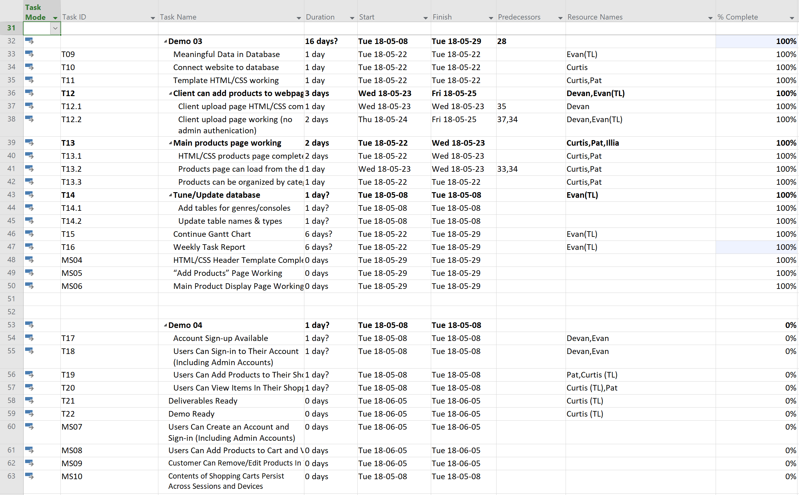

|  |
| --- |
| **Git Log** |

